Customization instructions for PxWeb

Table of contents

Revision history 2

Introduction 4

Structure 4

Images and paths 6

Styles 7

Code 9

# Introduction

This document provides a short description of a possible approach to customize PxWeb to get the look and feel of an existing website. The instruction is written in conjunction with a project with aim to customize PxWeb to appear integrated with Statistics Sweden´s website [www.scb.se](http://www.scb.se), hence the steps and the examples below are described with those conditions in mind.

Basic knowledge about HTML, CSS and java script is needed to manage a successful customization.

The elements adjusted are images, styles, texts and links, where images and styles affects the file structure of the website while texts and links is changed by code and text modifications in the existing PxWeb files.

# Structure

To keep control of modifications of PxWeb and be able to keep changes in an easy way even if a new setup of the website is done, it is a good idea to set up a separate structure that contains the modifications. In this case this is made by adding customization folder called “SCB” below the “Resources” folder in the PxWeb installation.

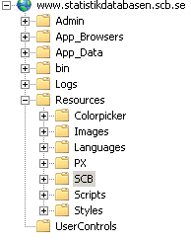

Images

In the customization folder “SCB” folder structures for two sets of image types is created.

1. The default graphical elements for PxWeb (the content of “\PXWeb\Resources\Images” folder in the PxWeb installation). Some or all of those images may be replaced to match the new look of the website and to keep control of the changes , they are copied into a separate folder which in this example is called “SSD”. An example of PxWeb original graphical elements is “mandatory.gif”: , which is used to mark mandatory variables.
2. The graphical elements that is not originally a part of PxWeb, but will be used in the customized website as additions or referenced by imported style sheets. Since the goal is to get the PxWeb installation to appear like [www.scb.se](http://www.scb.se) with a minimum of changes, the folder structure for images and its content is copied from that site and pasted into the “Images”-folder in the customization folder “SCB”.

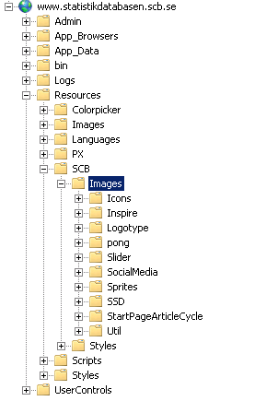

Styles

In customization folder “SCB” a sub folder is created that will contain all style sheets for the site we want to mimic. The folder is called “Styles” and the style sheets from [www.scb.se](http://www.scb.se) is copied into that.

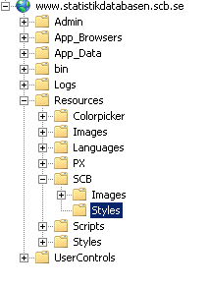

# Images and paths

The set of default graphical elements for PxWeb that is going to be used in this customization of PxWeb were in a previous step copied into a new location in the “customization folder”. The image path setting in PxWeb administration therefore has to be changed to reflect the new path. That is made by changing the setting “Image path” in PxWeb administration interface.

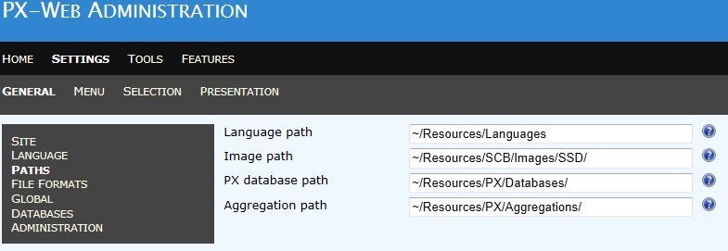

When an original graphical element for PxWeb are replaced in the customized version, the new image should be named as the image they replace. The image is then put in the designated folder below the customization folder. In this example the replacement images are put in “Resources/SCB/Images/SSD”.

# Styles

All styles used in the customized installation of PxWeb are defined in the PxWeb style sheets and in the style sheets added to the customization folder.

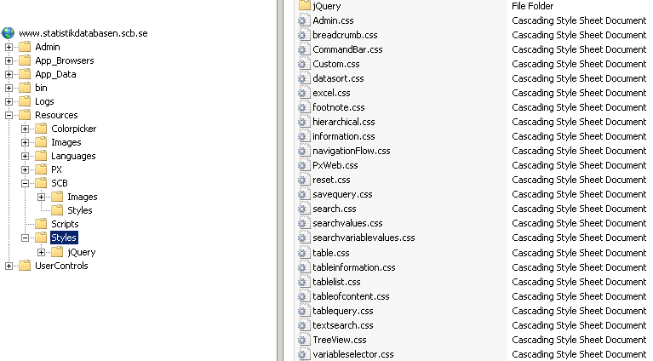

*Style sheets included in PxWeb is located under [Site]/Resources/Styles*

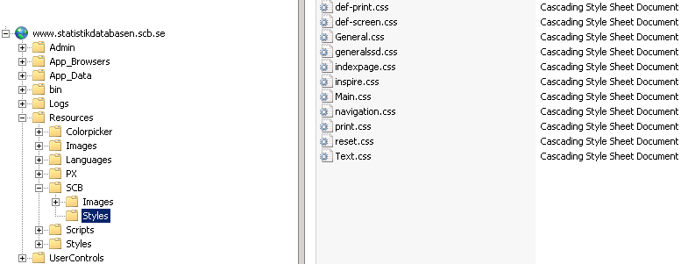

*Style sheets copied from another website, in this case* [*www.scb.se*](http://www.scb.se)*, are added to the customization folder.*

Some of the styles defined in either the original PxWeb style sheets or in the imported style sheets probably has to be changed to get the exact right layout. All style additions, changes and extensions are made in the Custom.css file that is included in PxWeb.

If the style sheets imported from another website, in this example the style sheets from [www.scb.se](http://www.scb.se), contains image or file references, they have to be changed to reflect their new relative paths. With the file structure described in the example above the image paths in the style sheets will look like this: url('../Images/[*subfolder*]/[*name*]') .

For example the CSS properties for elements with id TopSearch and class icon14 are defined in the style sheets for [www.scb.se](http://www.scb.se) as

#TopSearch .icon14 {

height: 25px;

background: url('../Images/Sprites/scb_sprites_14px.png') -1px -32px no-repeat;

}

The image reference in the customized PxWeb solution are then changed by the following addition to Custom.css:

#TopSearch .icon14 {

background: url('../SCB/Images/Sprites/scb_sprites_14px.png') -1px -32px no-repeat;

}

# Code

Links to style sheets and script files

Links to style sheets and script files with content common for all parts of PxWeb are placed inside the <head> element in top of PxWeb.master. The style sheets and in the customization folder should also be added there, just above Custom.css so that their contents overrides all other styles except the styles in Custom.css. Custom.css is as mentioned above the file where all modifications and extensions to the base styles are made. For the same reasons all script files (if any) in the customization folder should be linked to just above the link to the file Custom.js.

**Example:** Below is a part of the code in PxWeb.master with the style sheets “def-screen.css” and “main.css” added from the customization folder.

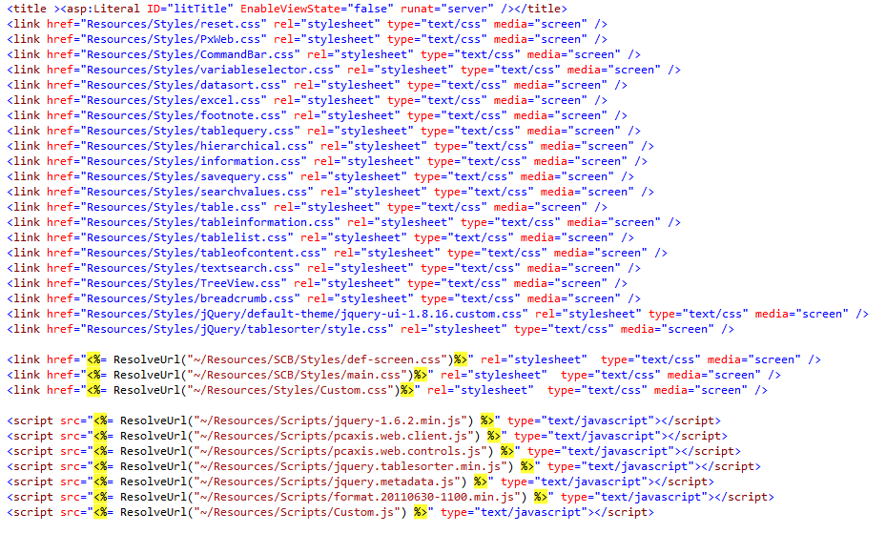

Hide original PxWeb content

When the PxWeb site is customized some of the original elements maybe has to be removed and/or be replaced by other elements. Since there are plenty of server elements (elements with the property runat="server") it is often not possible to just remove that parts of the code.

One way to safely remove parts of the content in a PxWeb page is to hide it by applying a class on those elements.

**Example:** The div “header” is changed so that it is not displayed or takes any space in the page.

The class “hide” is added to Custom.css:



This class is used to hide the div “header” in PxWeb.master

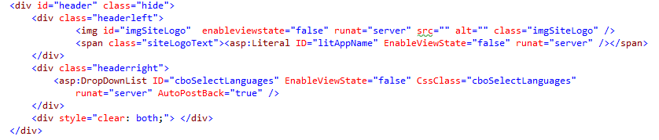

The class “hide” is possible to use for all elements in the .aspx-pages, but if the element to hide is a server control it is more efficient to hide the element and its children using the property “Visible” since that affects the code output from the server.

**Example:** The visibility for the footnote control is changed so that neither the control or elements contained in it is rendered from the server.

<pxc:Footnote ID="SelectionFootnotes" runat="server" Visible="false" />

Adding content

It is possible to add HTML and script content to all .aspx- and .ascx-files in PxWeb.

To insert a specific text or add a link, the recommended way is to use the language files.

**Example:** Add a link with text to a page in PxWeb

The following lines are added to pxlang.xml:

<sentence name="MyCustomLinkUrl" value="http://www.scb.se" />

<sentence name="MyCustomLinkText" value="Visit SCB" />

This code is added in the .aspx-file where the link should be displayed

<a href="<% =Master.GetLocalizedString("MyCustomLinkUrl") %>">

<% =Master.GetLocalizedString("MyCustomLinkText") %></a>